 

Assignment - 2

|  |  |
| --- | --- |
| **Student Name/ID Number:** | Wildan Luqmanul Hakim/BDSE04-0322 |
| **Academic Year:** | 2022 |
| **Unit Assessor:** | Arvinder Kaur |
| **Project Title:** | Assignment 2– Spring MVC |
| **Issue Date:** | 23 November 2022 |
| **Submission Date:** | 24 November 2022 |
| **Internal Verifier Name:** |  |
| **Date:** | 24 November 2022 |

|  |
| --- |
| **Learner declaration** |
| I certify that the work submitted for this assignment is my own and research sources are fully acknowledged.    Student signature: Date: 24 November 2022 |

|  |  |  |  |  |  |
| --- | --- | --- | --- | --- | --- |
| **Module No:** | 1 | **IU No:** | 2 | **Exercise No.** | 1 |

|  |  |
| --- | --- |
| **Lab Assessment Statement** | **Assignment 2 - Spring MVC**  **You are developing a "Know-Your-Neighborhood" application. The goal of this application is to provide details on all stores in the users neighborhood. For this to happen, the application should have a list of stores in the town. Hence, develop Entity, Controller, Service and DAO classes to add store to the system.**   1. **Create the Store Entity object with below fields.**    1. **String name**    2. **String phone_number**    3. **String[] localities // list of areas or localities the store serves** 2. **Develop a Controller class with a method to add Store to the system with POST HTTP method.  http://<host>:<port>/stores** 3. **Develop a Service class to add Store to the repository** 4. **Develop a DAO class that just adds given store to the list of stores maintained.**    1. **We didn’t go through the database module yet.**    2. **So just maintain a list of stores as a field (i.e., member variable) in DAO class.**    3. **Add a store object to that list.** |
| **Technical Environment** | - |
| **Guidelines** | - |
| **Duration** | 120 mins |

You are developing a "Know-Your-Neighbourhood" application. The goal of this application is to provide details on all stores in the user’s neighbourhood. For this to happen, the application should have a list of stores in the town. Hence, develop Entity, Controller, Service and DAO classes to add store to the system.

1. Create the Store Entity object with below fields.

a. String name

b. String phone_number

c. String [] localities // list of areas or localities the store serves

Figure 1 – Model (Store.java)  
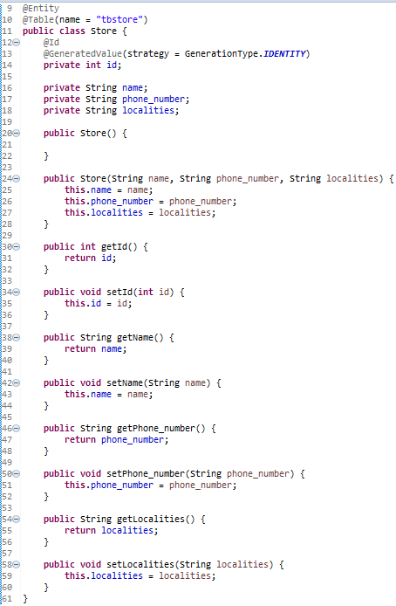

2. Develop a Controller class with a method to add Store to the system with POST HTTP method. http://:/stores

Figure 2 – Controller (StoreController.java)

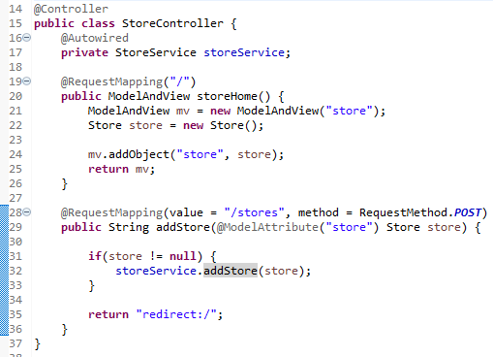

3. Develop a Service class to add Store to the repository

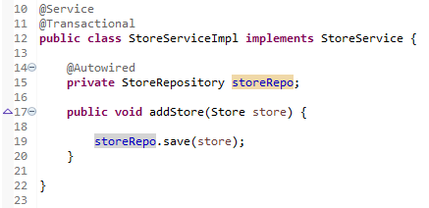

4. Develop a DAO class that just adds given store to the list of stores maintained.

a. We didn’t go through the database module yet.

b. So just maintain a list of stores as a field (i.e., member variable) in DAO class.

c. Add a store object to that list.

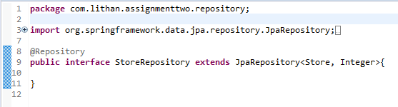

5.--------------Table------------------------------------



**---------------------------------Assignment 2 -- Spring MVC -- Result ----------------------------**

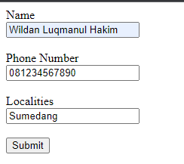

After Submit

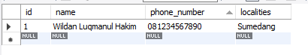

**Source Code:**

